Article
TD3-Based Adaptive Navigation Control of UAVs for High-precision Expressway Service Area Mapping
Kaiqing Huang ¹, Juncheng Zeng ², Chang Liu ¹, Wenhan Huang ², Yong Wang ¹, Chenhao Wu ², Xiaoyu Xin ¹, Xinyuan Wang ², Jishi Zheng ³, Weicheng Gu ³ and Dewang Chen ³
Academic Editor: Firstname Lastname
Received: date
Revised: date
Accepted: date
Published: date
Copyright: © 2026 by the authors. Submitted for possible open access publication under the terms and conditions of the Creative Commons Attribution (CC BY) license.
¹ Fujian Fuquan Expressway Co.Fuzhou, 350001 CN
² Fujian Expressway Science and Technology Innovation Research Institute Co.,Fuzhou, 350001 CN
³ Transportation Engineering Department, Fujian University of Technology, Fuzhou, 350001 CN
* Correspondence: guweicheng@smail.fjut.edu.cn
Abstract
This study proposes a Twin Delayed Deep Deterministic Policy Gradient (TD3)-based adaptive navigation-control method for fixed-wing unmanned aerial vehicles (UAVs) to improve three-dimensional conical spiral trajectory tracking in high-precision map-ping tasks for mountainous expressway service areas. Unlike fixed-gain navigation control, the proposed method uses a continuous-action reinforcement learning policy to adjust the heading and altitude navigation gains online according to real-time tracking states, including radial error, altitude error, flight progress, and disturbance conditions. The TD3 controller is integrated with a three-dimensional conical spiral navigation framework and trained in an ArduPilot–Gazebo Software-in-the-Loop (SITL) environment. Simulation experiments are conducted under both no-wind and 5 m/s wind-disturbance conditions using multiple initial test scenarios. The results show that the proposed controller significantly improves radial tracking accuracy and altitude-following consistency compared with the FixedGain K = 0.8 baseline. Under no-wind conditions, TD3 reduces the radial RMSE from 4.752 m to 0.159 m. Under wind disturbance, TD3 improves the completion rate from 16/20 to 17/20 and reduces the radial RMSE from 8.139 m to 5.218 m over the common completed scenarios. Multi-scenario analysis further confirms that TD3 provides more stable tracking performance under different initial positions and headings. These results indicate that the proposed TD3-based adaptive navigation controller is effective for improving fixed-wing UAV conical spiral tracking and has potential for high-precision mapping applications in complex expressway service-area environments.
Keywords: Navigation Control; TD3; trajectory tracking; conical spiral trajectory; Expressway Service Area; High-precision Mapping

1. Introduction
The rise of autonomous driving has brought new challenges to expressway service areas, which are complex environments featuring gas stations, convenience stores, public restrooms, charging stations, and parking spaces for various types of vehicles. These areas present significant obstacles for autonomous vehicles due to their intricate layouts and diverse functionalities[1]. Moreover, the gradual implementation of autonomous cleaning vehicles in expressway service areas further emphasizes the need for enhanced mapping solutions. In this context, the construction of high-precision maps for expressway service areas has become increasingly crucial[2-3]. These maps not only facilitate safer and more efficient autonomous driving but also support the operation of various automated services within these areas, ultimately improving the overall user experience and safety on expressways.
The construction of high-precision maps typically relies on aerial photography using fixed-wing UAVs. This process involves setting ground control points as coordinate references and employing Real-Time Kinematic (RTK) technology to achieve high accuracy in the generated maps[4-8]. Traditional fixed-altitude aerial photography techniques, when applied to regions with significant topographic variation, often result in substantial disparities in elevation across individual image pixels. These disparities can introduce considerable errors in the resulting high-precision maps, particularly for expressways and their associated service areas situated in mountainous terrains with substantial elevation differences. The creation of accurate, high-resolution maps for such challenging environments remains a significant obstacle in the field of aerial surveying and mapping.
To address this issue, an innovative approach involves programming fixed-wing UAVs to navigate along 3D curved trajectories. This method aims to maintain a more consistent altitude relative to the terrain, thereby minimizing elevation differences between captured image pixels. For 3D UAV navigation control, researchers have developed various algorithms including Vector Field (VF)[9], Pure Pursuit with Line-of-Sight (PLOS)[10], Linear Quadratic Regulator (LQR)[11], L1-Navigation[12], and PID control[13-14]. L1-Navigation and VF control have been implemented in open-source platforms such as ArduPilot and Paparazzi, primarily for waypoint tracking and path-following tasks[15]. However, these algorithms are generally designed with fixed or manually tuned control parameters. When applied to complex 3D trajectories under wind disturbances and terrain variations, their adaptability and tracking accuracy may be limited.
The advancement of artificial intelligence has propelled reinforcement learning (RL) methods to the forefront of UAV flight control research. Recent literature demonstrates a wide array of applications in this domain[16]. Researchers have formulated autonomous thermalling as a partially observable Markov decision process to identify and exploit thermal updrafts, thereby extending UAV flight endurance[17]. Others have designed Deep Deterministic Policy Gradient (DDPG) algorithms with continuous action spaces to train UAVs to navigate through obstacles and reach specified targets[18]. Policy-gradient and actor–critic methods, such as Proximal Policy Optimization (PPO) and other deep RL frameworks, have also been applied to UAV guidance, formation control, and nonlinear flight-control task[19-21]. These studies indicate that deep reinforcement learning has strong potential for improving UAV autonomy and robustness in complex flight environments[22].
Despite these advancements, current spatial 3D navigation control methods often rely on fixed acceleration calculation parameters. This limitation leads to reduced flight tracking accuracy and an inability to self-adjust flight acceleration in response to external disturbances, particularly in challenging scenarios such as high-precision mapping of expressway service areas in mountainous regions. To address these issues, this paper proposes an enhanced approach by integrating the TD3 algorithm into 3D Conical Spiral Navigation Flight Control (3DCSNFL). The conical spiral (CS) trajectory is especially suited for mountainous terrains, as it allows UAVs to navigate through narrow spaces at lower altitudes while gradually ascending, enabling the capture of high-quality images throughout the flight path. This approach optimizes the balance between flight constraints in complex topographies and the need for detailed, high-resolution mapping data.
Compared with tabular Q-learning, TD3 is more suitable for the adaptive control problem considered in this study because it can directly handle continuous state and action spaces. In the proposed framework, the TD3 agent does not need to discretize the UAV tracking state into a limited number of categories or restrict the action to simple gain-increase, gain-decrease, and gain-unchanged operations. Instead, it learns a continuous policy for navigation-gain adjustment according to real-time flight states, including radial tracking error, altitude error, flight progress, and disturbance conditions. The TD3 algorithm improves the stability of deterministic policy learning by using clipped double Q-learning, delayed policy updates, and target policy smoothing, which can reduce overestimation bias and improve learning robustness in continuous-control tasks[23].
Therefore, by integrating TD3 with 3DCS navigation, the proposed method provides a practical and adaptive solution for UAV flight control in complex mountainous environments. The proposed controller is trained and evaluated in an ArduPilot–Gazebo Software-In-The-Loop (SITL) simulation environment, where the learned policy adaptively regulates the navigation gain during conical spiral tracking. This framework aims to improve tracking accuracy, disturbance rejection, and terrain-relative altitude consistency, thereby enhancing the suitability of UAV-based high-precision mapping for expressway service areas.

2. Three-Dimensional Conical Spiral Navigation Control

2.1. UAV dynamics model
This paper focuses on an external navigation-control loop that enables fixed-wing UAVs to track spatially curved paths by adjusting navigation-control parameters. It is assumed that the CS trajectory to be tracked is generated according to the fixed-wing UAV dynamics, and its kinematic model in three-dimensional space is expressed as follows[12]:
$$\begin{aligned}\left.\begin{aligned}&\dot{x}=V\cos{γ}\cos{ψ} \\ &\dot{y}=V\cos{γ}\sin{ψ} \\ &\dot{z}=-V\sin{γ} \\ &\dot{ψ}=\frac{g}{v}tan{ϕ}\end{aligned}\right\}\#\left(1\right)\end{aligned}$$
where $(\overset{˙}{x},\overset{˙}{y},\overset{˙}{z})$ denotes the velocity components of the UAV in the $x$, $y$, and $z$ directions, respectively; $V$ is the flight speed of the UAV; $γ$ is the flight-path angle; $ψ$ is the yaw angle; $ϕ$ is the roll angle; and $g$ is the gravitational acceleration.

2.2. 3D CSNFL algorithm
This section describes the three-dimensional conical spiral navigation flight control (3DCSNFL) algorithm. The CS curve is shown in Figure 1. During flight, the UAV tracks a variable-pitch conical spiral trajectory, in which the CS flight radius and the UAV flight altitude gradually change with the UAV azimuth angle.
Figure 1. Variable pitch cone CS.
The mathematical equations of the parameters of the variable pitch CS curve model are as follows：
$$\begin{aligned}\left.\begin{aligned}&x=ae^{k^{'}η_{r}}\cos{η_{r}} \\ &y=ae^{k^{'}η_{r}}\sin{η_{r}} \\ &z=be^{k^{'}η_{r}}\end{aligned}\right\}\#\left(2\right)\end{aligned}$$
In the equation:$k^{'}=\sin{α}\cos{β}$ ($k^{'}$,$α$and $β$ are constants,; $β$ is the helix angle of the variable pitch conical helix);$η_{r}$ is the rotation angle of the rotation curve $\left(0≤η_{r}≤2π\right)$；$b=a\cos{α}$，$a$ is constant. Converting the spatial right-angle coordinate system into the Frenet-Serret coordinate system, the curve equation is shown in the following equation：
$$\begin{aligned}r=\left\{ae^{k^{'}η_{r}}\cos{η_{r}},ae^{k^{'}η_{r}}\sin{η_{r}},be^{k^{'}η_{r}}\right\}\#\left(3\right)\end{aligned}$$
The radius $R_{c}$ of the CS in the plane polar coordinate system is defined as：
$$\begin{aligned}R_{c}=r_{a}+δ\#\left(4\right)\end{aligned}$$
In the equation：$0≤R_{c}≤R$,$r_{a}$ is the horizontal projection of the distance from the UAV to the target waypoint;$δ$ is the azimuth of the UAV to the target waypoint; The distance from the center of the sphere to the center of the helix and the position vector from the center of the helix to the helix are as follows：
$$\begin{aligned}H=h+R_{c}\cot{θ_{t}}\#\left(5\right)\end{aligned}$$
$$\begin{aligned}r_{c}=He_{rc}\#\left(6\right)\end{aligned}$$
In the equation:$h$ is the altitude of the UAV when the spiral flight is not executed. In order to make the UAV automatically track the CS curve flight, the flight altitude increases gradually during the flight.
In the spatial CS curve navigation algorithm, the position vector of the spatial conical spiral line points is：
$$\begin{aligned} r\left(δ\right)=\frac{R_{c}}{{\sin{θ}}_{t}}\left[e_{θ_{c}},e_{ψ_{c}},-e_{r_{c}}\right]\left[\begin{matrix}{\sin{θ}}_{t}\cos{δ} \\ σ{\sin{θ}}_{t}\sin{δ} \\ -{\cos{θ}}_{t}\end{matrix}\right]=\frac{R_{c}}{{\sin{θ}}_{t}}\left[{\cos{θ}}_{t}e_{r_{c}}+{\sin{θ}}_{t}\left(\cos{δ}e_{θ_{c}}+σ\sin{δ}e_{ψ_{c}}\right)\right]\#\left(7\right)\end{aligned}$$
$$\begin{aligned}r\left(δ\right)=-v_{c}\left(\sin{δ} e_{θ_{c}}-σ \cos{δ} e_{ψ_{c}}\right)\#\left(8\right)\end{aligned}$$
In the equation: $v_{c}=R_{c}\dot{δ}$. Projection of the position vectors of the points on the helix in the transverse plane and in the height direction, respectively:
$$\begin{aligned} r\left(δ\right)=\frac{R_{c}}{{\sin{θ}}_{t}}\left[e_{θ_{c}},e_{ψ_{c}},-e_{r_{c}}\right]\left[\begin{matrix}{\sin{θ}}_{t}\cos{δ} \\ σ{\sin{θ}}_{t}\sin{δ} \\ -{\cos{θ}}_{t}\end{matrix}\right]=\frac{R_{c}}{{\sin{θ}}_{t}}\left[{\cos{θ}}_{t}e_{r_{c}}+{\sin{θ}}_{t}\left(\cos{δ}e_{θ_{c}}+σ\sin{δ}e_{ψ_{c}}\right)\right]\#\left(7\right)\end{aligned}$$
$$\begin{aligned}z\left(δ\right)=-\frac{R_{c}}{{\sin{θ}}_{t}}\left({\cos{θ}}_{t}{\sin{θ}}_{c}-\cos{δ}{\cos{θ}}_{t}{\sin{θ}}_{c}\right)\#\left(10\right)\end{aligned}$$
The normal and tangential vectors of the CS projected in the transverse plane are:
$$\begin{aligned}e_{tl}\left(δ\right)=-\frac{\sin{δ}\cos{θ_{c}}e_{1}-σ\cos{δ}e_{2}}{\sqrt{\cos^{2}{δ}+\sin^{2}{δ}\cos^{2}{θ_{c}}}}\#\left(11\right)\end{aligned}$$
$$\begin{aligned}e_{nl}\left(δ\right)=-\frac{\cos{δ}e_{1}-σ\sin{δ}\cos{θ_{c}}e_{2}}{\sqrt{\cos^{2}{δ}+\sin^{2}{δ}\cos^{2}{θ_{c}}}}\#\left(12\right)\end{aligned}$$
The curvature$k_{l}$ of the tapered helix in the transverse plane projection is calculated from the tangent vector as：
$$\begin{aligned}\frac{∂_{δ}e_{tl}\left(δ\right)}{\left|∂_{δ}r_{l}\left(δ\right)\right|}=-k_{l}\left(δ\right)e_{nl}\left(δ\right)\#\left(13\right)\end{aligned}$$
Which：
$$\begin{aligned}k_{l}\left(δ\right)=\frac{\cos{θ_{c}}}{R_{c}{\sqrt{\cos^{2}{δ}+\sin^{2}{δ}\cos^{2}{θ_{c}}}}^{3}}\#\left(14\right)\end{aligned}$$
Deriving the projection $r_{l}\left(δ\right)$ of the CS in space in the transverse plane, the transverse velocity of the point on the curve is obtained as：
$$\begin{aligned}v_{l}\left(δ\right)=\left|r_{l}\left(δ\right)\right|=v_{c}\sqrt{\cos^{2}{δ}+\sin^{2}{δ}\cos^{2}{θ_{c}}}\#\left(15\right)\end{aligned}$$
Then the centripetal acceleration of the curve is：
$$\begin{aligned}a_{l}\left(δ\right)=v_{l}^{2}\left(δ\right)k_{l}\left(δ\right)=\frac{v_{c}^{2}cos{θ_{c}}}{R_{c}\sqrt{\cos^{2}{δ}+\sin^{2}{δ}\cos^{2}{θ_{c}}}}\#\left(16\right)\end{aligned}$$
During the flight of the drone, there is a certain trajectory error between the actual flight path and the expected trajectory. The position vector of the UAV in Figure 2 is $r_{a}$, The error vector of the spatial trajectory of the drone from the conical helix is $r_{d}$, Then the position vector of the closest point to the UAV on the expected trajectory is:
$$\begin{aligned}r_{p}=He_{r_{c}}+R_{c}e_{np}\#\left(17\right)\end{aligned}$$
In the equation:$e_{np}$ is the external normal vector of the nearest point.
The tangent vector $e_{tp}$ and the external normal vector $e_{np}$ of the nearest point to the UAV are respectively：
$$\begin{aligned}\left\{\begin{aligned}e_{tp}=σ\frac{r_{a}×e_{r_{c}}}{\left|r_{a}×e_{r_{c}}\right|} \\ e_{np}=σe_{r_{c}}×e_{tp} \end{aligned}\right.\#\left(18\right)\end{aligned}$$
The 3D spatial trajectory error vector is$r_{d}=r_{a}-r_{p}$, The trajectory error in the lateral projection vector is $r_{dl}=r_{d}-r_{d,3}e_{3}$, where$r_{d,3}$ is trajectory error vector in the direction of the longitudinal axis, $e_{3}$ is base vector in the direction of the vertical axis.
The trajectory error of the lateral projection is:
$$d_{l}=\operatorname{sgn}{(}r_{dl}⋅e_{npl})\left|r_{dl}\right| (19)$$
In the equation:$e_{npl}$ is the projection of the external normal vector onto the horizontal plane.
The projection of the velocity vector in the transverse direction $v_{pal}$and the normal component of velocity $V_{l}$are expressed in 20:
$$\begin{aligned}\left\{\begin{aligned}v_{pal}=v_{a}-v_{a,3}e_{3} \\ V_{l}=v_{pal}⋅e_{npl}\end{aligned}\right.\#\left(20\right)\end{aligned}$$
Thus, it can be concluded that the acceleration of UAV in the process of tracking the CS flight is:
$$\begin{aligned}a_{p}=a_{1}+K_{r}d_{l}+K_{v}V_{l}\#\left(21\right)\end{aligned}$$
where $K_{r}$ and $K_{v}$ are navigation gain coefficients associated with the lateral position error and the normal velocity component, respectively. These gain coefficients directly affect the acceleration command during CS trajectory tracking[12-14]. Therefore, they provide adjustable control parameters for the TD3-based adaptive navigation controller developed in the next section.

3. TD3-Based Adaptive Control Design for Conical Spiral Navigation

3.1. TD3 Algorithm Principle
According to Equation (21), the UAV acceleration during conical spiral tracking is determined by the navigation gain coefficients. In conventional flight tests, these gain coefficients are usually fixed constants. As a result, when a fixed-wing UAV is subjected to external disturbances, such as wind, it cannot adaptively adjust its gain settings, which may lead to trajectory deviation and reduced flight stability. To address this limitation, this section introduces a deep reinforcement learning module into the three-dimensional conical spiral navigation algorithm, with the aim of improving UAV trajectory-tracking accuracy and enhancing disturbance-rejection capability.
Reinforcement learning (RL) algorithms have been widely used in robotic learning and navigation in recent years. In RL, an agent interacts with the environment and learns an optimal policy by maximizing the cumulative reward. In practice, an RL problem can be formulated as a Markov Decision Process (MDP)[24], which is represented by the five-tuple:
$$\begin{aligned}M=⟨S,A,P,R,γ⟩\#(22)\end{aligned}$$
where $S$ denotes the state space, and $s∈S$ represents the environmental state perceived by the agent; $A$ denotes the action space, and $a∈A$ represents the action selected by the agent; $P$ denotes the state-transition probability after action $a$ is executed; $R$ denotes the reward function; and $γ∈[0,1]$ is the discount factor. In the UAV conical spiral tracking task, the flight state is affected by nonlinear fixed-wing dynamics, wind disturbance, tracking deviation, altitude variation, and command response. Therefore, the exact state-transition model is difficult to obtain, and a model-free deep reinforcement learning method is adopted in this study.
The TD3 algorithm is an off-policy actor–critic deep reinforcement learning method designed for continuous-control tasks. Compared with tabular Q-learning, TD3 does not require the discretization of the state and action spaces. This characteristic is suitable for the adaptive navigation-gain control problem considered in this paper, because the radial tracking error, altitude error, flight progress, and gain command are all continuous variables. In the proposed framework, the TD3 agent learns a deterministic policy that maps the current UAV flight state to a continuous navigation-gain action.
Figure 2 shows the framework of the proposed TD3-based adaptive navigation controller. The ArduPilot–Gazebo Software-In-The-Loop (SITL) environment is used as the interaction environment. At each control step, the online actor network receives the current flight state $s_{t}$ and outputs an action $a_{t}$, which is used to adjust the navigation gain of the 3D conical spiral navigation controller. After the action is executed in the SITL environment, the environment returns the next state $s_{t+1}$ and reward $r_{t}$. The transition sample $(s_{t},a_{t},r_{t},s_{t+1},d_{t})$ is stored in the replay buffer, where $d_{t}$ denotes the terminal flag. During training, mini-batches are randomly sampled from the replay buffer to update the actor and critic networks.

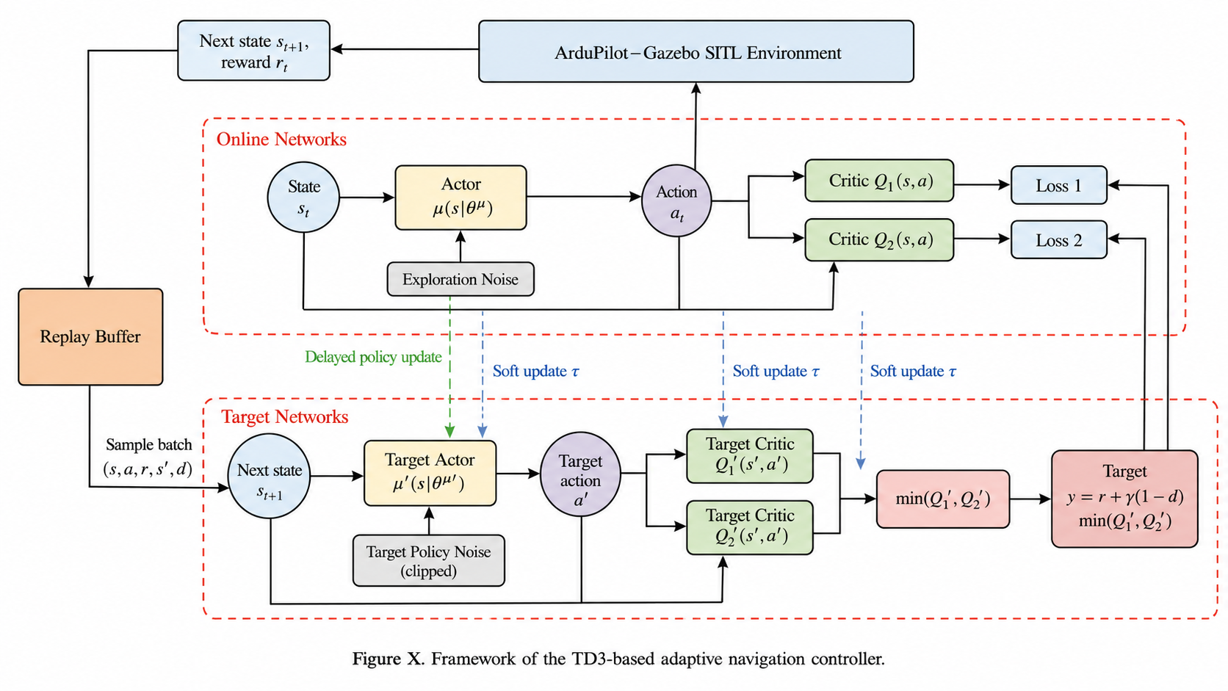
Figure 2. Framework of the TD3-based adaptive navigation controller.
In the online network, the actor generates the action according to the deterministic policy:
$$\begin{aligned}a_{t}=μ_{θ}(s_{t})+ϵ_{t}\#(23)\end{aligned}$$
where $μ_{θ}$ denotes the actor network with parameter $θ$, $s_{t}$ is the current state, $a_{t}$ is the selected action, and $ϵ_{t}$ is the exploration noise added during training. In this study, the action corresponds to the adaptive adjustment of the navigation gain used by the 3DCS navigation controller. The actor output is constrained within the predefined gain range to ensure that the generated control action remains feasible for fixed-wing UAV flight.
TD3 uses two critic networks to estimate the action-value function, denoted as $Q_{ϕ_{1}}(s,a)$ and $Q_{ϕ_{2}}(s,a)$. The use of double critics reduces the overestimation bias that may occur in deterministic actor–critic learning. For each sampled transition, the target actor first generates the target action for the next state:
$$\begin{aligned}{\overset{˜}{a}}_{t+1}=clip\left(μ_{θ^{'}}(s_{t+1})+clip(ϵ,-c,c),a_{min},a_{max}\right)\#(24)\end{aligned}$$
where $μ_{θ^{'}}$ is the target actor network, $ϵ$ is the target policy smoothing noise, $c$ is the noise clipping bound, and $a_{min}$ and $a_{max}$ are the lower and upper bounds of the action space. The target Q-value is then calculated using the smaller value of the two target critic networks:
$$\begin{aligned}y_{t}=r_{t}+γ(1-d_{t})\min_{i=1,2} Q_{ϕ_{i}^{'}}(s_{t+1},{\overset{˜}{a}}_{t+1})\#(25)\end{aligned}$$
where $Q_{ϕ_{1}^{'}}$ and $Q_{ϕ_{2}^{'}}$ are the two target critic networks. This clipped double-Q mechanism suppresses overoptimistic value estimation and improves the robustness of policy learning.
The two critic networks are updated by minimizing the mean squared Bellman error:
$$\begin{aligned}L(ϕ_{i})=\frac{1}{N}\sum_{j=1}^{N}{ } {\left(Q_{ϕ_{i}}(s_{j},a_{j})-y_{j}\right)}^{2}, i=1,2\#(26)\end{aligned}$$
where $N$ is the mini-batch size sampled from the replay buffer. The actor network is updated by maximizing the Q-value estimated by the first critic network:
$$\begin{aligned}∇_{θ}J(θ)=\frac{1}{N}\sum_{j=1}^{N}{ } ∇_{a}Q_{ϕ_{1}}(s_{j},a)|_{a=μ_{θ}(s_{j})}∇_{θ}μ_{θ}(s_{j})\#(27)\end{aligned}$$
Different from DDPG, TD3 adopts a delayed policy-update strategy. The critic networks are updated at every training step, whereas the actor network and target networks are updated only after a fixed number of critic updates. This strategy allows the critic networks to provide more stable value estimates before the policy is updated. The target networks are updated using the following soft-update rule:
$$\begin{aligned}ϕ_{i}^{'}←τϕ_{i}+(1-τ)ϕ_{i}^{'}, θ^{'}←τθ+(1-τ)θ^{'}\#(28)\end{aligned}$$
where $τ$ is the soft-update coefficient. Through clipped double Q-learning, target policy smoothing, and delayed policy updates, TD3 improves the stability of continuous policy learning.
In this study, the TD3 algorithm is embedded into the ArduPilot–Gazebo SITL training framework. The SITL environment provides the UAV flight state, executes the navigation-gain action generated by the actor network, and returns the corresponding tracking reward. The replay buffer stores the interaction data collected during conical spiral tracking, and the online and target networks are updated according to the TD3 learning rule. In this way, the proposed method enables the fixed-wing UAV to learn an adaptive navigation-gain control policy from simulation interaction, thereby improving the adaptability of the 3D conical spiral navigation controller under external disturbances.

3.2. TD3 Algorithm to Optimize Navigation Control Flight
In this study, the TD3 algorithm is used to optimize the adaptive navigation-gain control of the fixed-wing UAV during three-dimensional conical spiral tracking. The proposed method directly models both the UAV flight state and the navigation-gain action as continuous variables. Therefore, it avoids manual state discretization and enables smoother gain adjustment during fixed-wing UAV trajectory tracking. This design is suitable for the continuous-control characteristics of conical spiral flight, where the UAV needs to adaptively respond to radial tracking error, altitude error, wind disturbance, and trajectory-progress variation.
The proposed TD3-based navigation controller is trained through online interaction with the ArduPilot–Gazebo Software-In-The-Loop (SITL) environment. At each control step, the environment provides the current UAV flight state, including tracking-error information, altitude-tracking information, flight progress, wind condition, and the current navigation-gain command. The actor network outputs a continuous action, which is then converted into the navigation gain used by the 3D conical spiral navigation controller. After the action is executed, the SITL environment returns the next flight state and reward. The transition sample is stored in the replay buffer and used to update the actor and critic networks.
The state space is designed to describe the real-time tracking condition of the UAV during conical spiral flight. In the implementation, the recorded flight information includes radial tracking error, altitude error, flight progress, wind speed, current gain, target position, command heading, heading correction, target altitude, command altitude, and altitude correction. Based on these variables, the state vector can be expressed as:
$$\begin{aligned}s_{t}={\left[{\overset{‾}{d}}_{r,t},{\overset{‾}{e}}_{z,t},{\overset{‾}{e}}_{c,t},{\overset{‾}{e}}_{ψ,t},p_{t},{\overset{‾}{W}}_{t},{\overset{‾}{K}}_{h,t-1},{\overset{‾}{K}}_{z,t-1}\right]}^{T}\#(29)\end{aligned}$$
where $d_{r,t}$ denotes the radial tracking error, $e_{z,t}$ denotes the altitude error, $e_{c,t}$ denotes the cross-track error, $e_{ψ,t}$ denotes the heading error, $p_{t}$ denotes the flight progress, $W_{t}$ denotes the wind speed, $K_{h,t-1}$ denotes the heading navigation gain at the previous step, and $K_{z,t-1}$ denotes the altitude navigation gain at the previous step. The overbar represents normalized variables. When only heading-gain adaptation is considered, the altitude-gain-related term can be omitted from the state vector.
The action of the TD3 agent is defined as the adaptive adjustment of the navigation gain. In the implementation, the action space supports two modes: heading-gain control and heading-altitude gain control. Therefore, the continuous action space is defined as:
$$\begin{aligned}a_{t}∈[-1,1]^{m}, m=1\text{ or }2\#(30)\end{aligned}$$
where $m=1$ indicates that the TD3 agent only outputs the heading navigation-gain action, and $m=2$ indicates that the TD3 agent outputs both heading and altitude navigation-gain actions. In the absolute-gain mode, the actor output is mapped to the actual gain range as follows:
$$\begin{aligned}K_{h,t}=K_{min}+\frac{a_{h,t}+1}{2}\left(K_{max}-K_{min}\right), K_{z,t}=K_{z,min}+\frac{a_{z,t}+1}{2}(K_{z,max}-K_{z,min})\#(31) \\ \end{aligned}$$
where $K_{h,t}$ is the heading navigation gain, $K_{z,t}$ is the altitude navigation gain, and $a_{h,t}$ and $a_{z,t}$ are the action components output by the actor network. $K_{min}$ and $K_{max}$ denote the lower and upper bounds of the heading navigation gain, while $K_{z,min}$ and $K_{z,max}$ denote the lower and upper bounds of the altitude navigation gain. If only heading-gain adaptation is used, only the first term in Equation (31) is applied.
The navigation gain generated by the TD3 actor is then used by the 3D conical spiral controller to correct the heading and altitude commands. The gain-based correction can be expressed as:
$$\begin{aligned}Δψ_{t}=clip\left(\frac{K_{h,t}d_{r,t}}{L_{corr}},-ψ_{max},ψ_{max}\right), h_{cmd,t}=h_{ref,t}+clip\left(K_{z,t}e_{z,t},-Δh_{max},Δh_{max}\right)\#(32) \\ \end{aligned}$$
where $Δψ_{t}$ denotes the heading correction, $h_{cmd,t}$ denotes the commanded altitude, $h_{ref,t}$ denotes the reference altitude, $L_{corr}$ is the heading-correction scale factor, $ψ_{max}$ is the maximum allowable heading correction, and $Δh_{max}$ is the maximum allowable altitude correction. This bounded correction mechanism prevents excessive command changes and improves the stability of fixed-wing UAV trajectory tracking.
The reward function is designed to guide the UAV to reduce tracking error, maintain altitude consistency, follow the reference conical spiral trajectory smoothly, and make continuous progress along the desired path. Since high-precision mapping requires both horizontal tracking accuracy and stable terrain-relative altitude, the reward function includes radial-error penalty, altitude-error penalty, cross-track-error penalty, heading-error penalty, action-smoothness penalty, progress reward, and safety-related penalty. The continuous reward can be expressed as:
$$\begin{aligned}r_{t}=-\left(w_{r}\frac{|d_{r,t}|}{d_{exp}}+w_{z}\frac{|e_{z,t}|}{z_{exp}}+w_{c}\frac{|e_{c,t}|}{d_{exp}}+w_{ψ}\frac{|e_{ψ,t}|}{π}\right)+w_{p}Δp_{t}-w_{s}‖a_{t}-a_{t-1}‖_{2}^{2}-c_{s}+b_{t}-f_{t}\#(33)\end{aligned}$$
where $d_{exp}$ and $z_{exp}$ are the expected radial-error and altitude-error bounds, respectively; $Δp_{t}$ denotes the increase in flight progress; $w_{r}$, $w_{z}$, $w_{c}$, $w_{ψ}$, $w_{p}$, and $w_{s}$ are the weights for radial error, altitude error, cross-track error, heading error, progress reward, and action smoothness, respectively; and $c_{s}$ is the step penalty. The corresponding tolerance thresholds and weight coefficients are specified in the experimental setup.
To further encourage the UAV to remain within the acceptable mapping-tolerance band and avoid unsafe flight states, an in-band bonus and a failure penalty are added:
$$\begin{aligned}b_{t}=b_{in}1\left(|d_{r,t}|≤d_{exp} ∩ |e_{z,t}|≤z_{exp}\right), f_{t}=c_{f}1\left(|d_{r,t}|>d_{term} ∪ h_{t}<h_{min}\right)\#(34)\end{aligned}$$
where $b_{in}$ is the in-band bonus, $c_{f}$ is the failure penalty, $d_{term}$ is the radial-error termination threshold, and $h_{min}$ is the minimum safe altitude. This reward design encourages the UAV to maintain both radial and altitude errors within the expected bounds, while penalizing large deviations and unsafe flight conditions.
The complete TD3-based adaptive navigation-control workflow is shown in Figure 3. First, the ArduPilot–Gazebo SITL environment and TD3 agent are initialized, and the 3D conical spiral reference trajectory is generated according to the mapping mission. Then, the environment is reset and the initial state is obtained. At each interaction step, the TD3 agent selects an action through random exploration or actor-network output with exploration noise. The selected action is mapped to the navigation gain and applied to the 3DCS navigation controller. After the command is executed in the SITL environment, the next state, reward, and terminal flag are obtained and stored in the replay buffer as a transition sample. When the update condition is satisfied, mini-batches are sampled from the replay buffer to update the two critic networks, the actor network, and the target networks according to the TD3 learning rule. This process is repeated until the episode terminates or the maximum number of steps is reached.
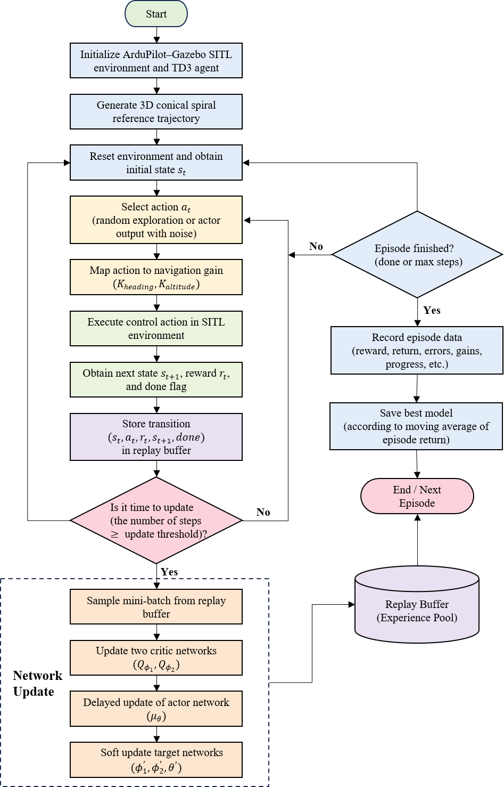
Figure 3. Online training flowchart of the TD3-based adaptive navigation controller.
During training, the interaction data, including reward, episode return, navigation gain, radial error, altitude error, and flight progress, are recorded for subsequent convergence and performance analysis. Through this design, the proposed TD3-based controller can continuously adjust the navigation gain according to the real-time tracking state of the UAV. The continuous-action design enables smoother gain variation and is suitable for fixed-wing UAV conical spiral tracking tasks in complex mountainous environments with wind disturbance and altitude variation.

4. SITL Simulation Experiments
To evaluate the online learning and trajectory-tracking performance of the proposed TD3-based adaptive navigation controller, simulation experiments were conducted using the ArduPilot–Gazebo Software-In-The-Loop (SITL) platform. The desired trajectory is a three-dimensional conical spiral curve designed for mapping-oriented fixed-wing UAV flight. During flight, the TD3 agent observes the real-time tracking state and outputs continuous gain-adjustment actions for the navigation controller.
The TD3 controller was trained online in the SITL environment for 200 episodes. Flight logs were recorded through MAVLink, including the actual UAV position, reference trajectory, radial tracking error, altitude tracking error, flight progress, episode reward, heading navigation gain, and altitude navigation gain. These data were used to analyze the training convergence and evaluate the trajectory-tracking performance of the learned TD3 policy.

4.1. Tracking Performance under Nominal Conditions
The SITL simulation environment used in this study is shown in Figure 4. Gazebo provides the flight scene and visualization environment, while ArduPilot is used as the autopilot for closed-loop fixed-wing flight control. The TD3 training program communicates with the simulated UAV through MAVLink, obtains real-time flight states, and sends navigation-gain adjustment commands to the conical spiral tracking controller.
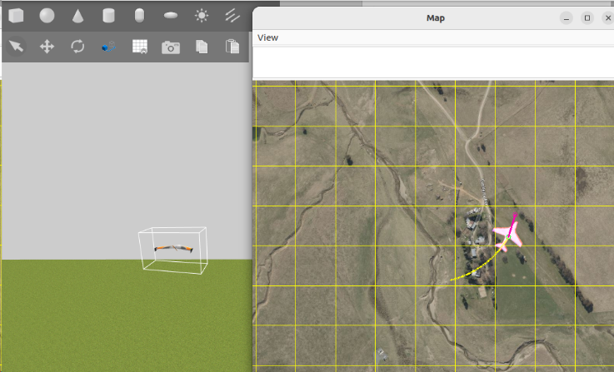
Figure 4. Fixed-wing UAV in the Gazebo–ArduPilot SITL flight simulation environment.
A Rascal 110 fixed-wing UAV model was adopted as the simulation object, and its main physical parameters are listed in Table 1. The UAV was required to track a three-dimensional conical spiral trajectory with three turns. The initial radius was set to 80 m, the radial increment was 80 m, the spiral start altitude was 30 m, and the total climb height along the spiral was 200 m. The commanded flight speed was 15 m/s, and the command frequency was 5 Hz. These settings were used to construct a representative fixed-wing UAV spiral mapping task in the SITL environment.
Table 1. Main parameters of the Rascal 110 fixed-wing UAV.
Parameter Name | Value
Wingspan /m | 2.794
Wing area /dm2 | 98.2
Length/m | 1.924
Takeoff weight /g | 4 990~5 897
Wing loading /g·dm-2 | 51~60
The main training parameters related to the TD3 agent are summarized in Table 2. The TD3 agent adopts an actor–critic framework with twin critic networks. The actor network outputs continuous gain-adjustment actions, while the critic networks evaluate the state-action values during training. The action space was defined as a heading–altitude gain adjustment space. Therefore, the output dimension of the actor network was set to 2, corresponding to the heading navigation gain and the altitude navigation gain. To avoid excessive control commands, both gains were constrained within the range of $[0.5,2.0]$.
Table 2. Training parameters related to the TD3 agent.
Parameter | Value
Max episodes | 200
Max steps per episode | 5000
Control interval | 0.2 s
Action dimension of output layer | 2
Action range | [0.5, 2.0]
Learning rate for actor / critic | $3×{10}^{-4}$/$3×{10}^{-4}$
Reward discount factor | 0.99
Experience replay buffer | $$2×{10}^{5}$$
Mini-batch size | 256
Exploration noise | 0.1
Target update and smoothing settings | $τ=0.005$, noise = 0.2, clip = 0.5
During online training, the reward function considered the radial tracking error, altitude tracking error, cross-track deviation, heading deviation, action smoothness, and flight progress. The reward of each episode was obtained by accumulating the step rewards over one complete conical spiral tracking task. Figure 5 shows the episode reward during the online TD3 training process. In the early training stage, the reward fluctuates because the agent explores the continuous action space and gradually accumulates flight samples in the replay buffer. As training proceeds, the reward increases and becomes more stable, indicating that the TD3 agent progressively learns an effective mapping from the real-time tracking state to the navigation-gain adjustment action.
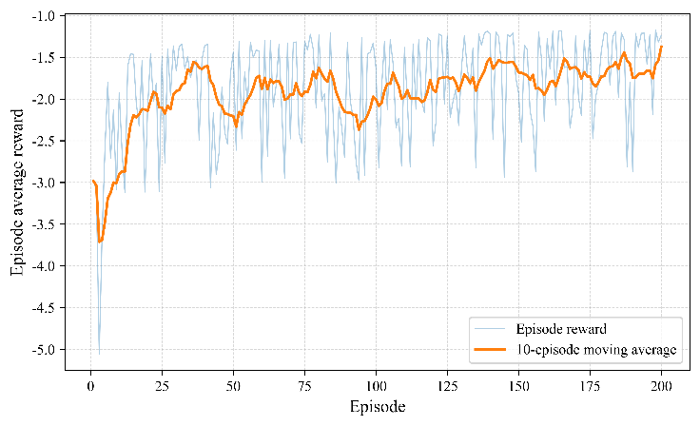
Figure 5. Episode reward during online TD3 training.
To further analyze the training process, the radial and altitude tracking errors over 200 training episodes are shown in Figure 6. Figure 6(a) presents the mean absolute radial error, radial RMSE, and maximum radial error. The radial error decreases rapidly after the initial exploration stage and remains at a relatively low level during the later training episodes. This indicates that the learned policy gradually improves the lateral tracking accuracy of the conical spiral trajectory. Figure 6(b) shows the corresponding altitude tracking error. Compared with the radial error, the altitude error remains more stable throughout the training process, and the mean and RMSE values are maintained at a sub-meter level. These results show that the TD3 agent can simultaneously improve radial tracking performance while maintaining stable altitude-following behaviour.
After online training, the trained TD3 policy was used for the subsequent trajectory-tracking evaluation. The actual flight trajectory, adaptive gain variation, and tracking error curves were analyzed to verify the effectiveness of the proposed TD3-based adaptive navigation controller in the conical spiral flight task.
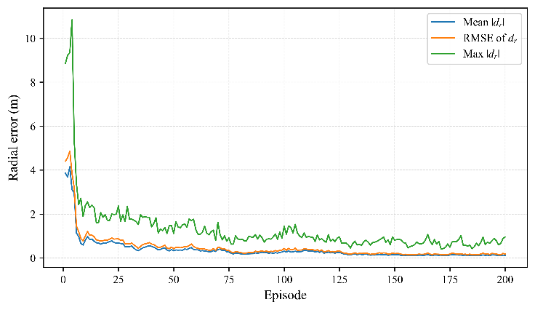 | 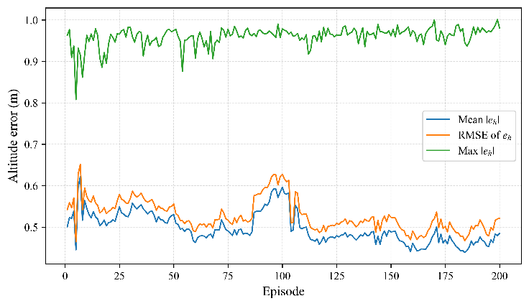
(a) | (b)
Figure 6. Tracking-error variation during online TD3 training. (a) Radial tracking error; (b) Altitude tracking error.

4.2. Trajectory-Tracking Performance under No-Wind Conditions
After online training, the learned TD3 policy was evaluated under nominal no-wind conditions. The fixed-gain conical spiral navigation controller with $K=0.8$ was selected as the baseline method. To ensure a fair comparison, both controllers were tested using the same set of 20 initial flight scenarios. During evaluation, no exploration noise was added, and both controllers were required to track the same three-dimensional conical spiral reference trajectory.
For quantitative analysis, only the flight phase satisfying $progress≥0.10$ was used for metric calculation. This setting removes the very early command-transition segment while retaining the main conical spiral tracking process. The evaluation metrics include the mean absolute radial error, radial RMSE, maximum radial error, mean absolute altitude error, altitude RMSE, maximum altitude error, and episode reward.
Figure 7 shows the trajectory-tracking comparison under no-wind conditions. The desired conical spiral trajectory is plotted as a dashed curve, while the actual flight trajectories of the fixed-gain controller and the TD3 controller are shown in the planar and three-dimensional views. Compared with the fixed-gain baseline, the TD3 controller tracks the reference spiral more closely and exhibits smaller radial deviation throughout the main spiral-tracking phase.
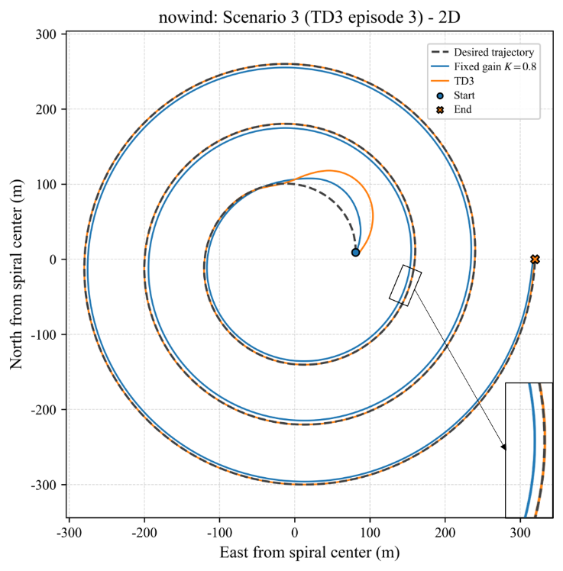 | 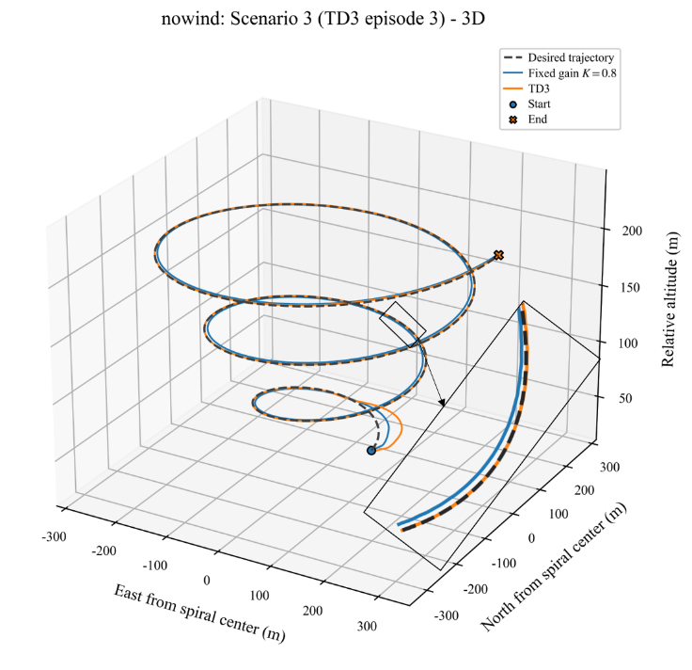
(a) | (b)
Figure 7. Trajectory-tracking comparison under no-wind conditions. (a) Planar projection of the conical spiral trajectory; (b) Three-dimensional conical spiral trajectory.
Table 3. Evaluation metrics under no-wind conditions.
Metric | Fixed Gain $K=0.8$ | TD3
Completed episodes ↑ | 20/20 | 20/20
Mean $|d_{r}|$ (m) ↓ | 4.684 ± 0.017 (4.712) | 0.099 ± 0.005 (0.114)
RMSE of $d_{r}$ (m) ↓ | 4.752 ± 0.009 (4.767) | 0.159 ± 0.028 (0.272)
Max $|d_{r}|$ (m) ↓ | 5.579 ± 0.006 (5.591) | 1.276 ± 0.755 (4.427)
Mean $|e_{h}|$ (m) ↓ | 0.509 ± 0.003 (0.513) | 0.397 ± 0.003 (0.403)
RMSE of $e_{h}$ (m) ↓ | 0.558 ± 0.005 (0.565) | 0.457 ± 0.005 (0.466)
Max $|e_{h}|$ (m) ↓ | 0.970 ± 0.168 (1.215) | 1.182 ± 0.232 (1.636)
Episode reward ↑ | -6392.465 ± 853.066 (-5624.431) | -2498.269 ± 860.996 (-1677.979)
Note: Values are reported as mean ± standard deviation (maximum) over 20 evaluation episodes. The symbol ↓ indicates that a smaller value is better, while ↑ indicates that a larger value is better.
As shown in Table 3, the TD3 controller significantly improves the radial tracking accuracy under no-wind conditions. Compared with the fixed-gain baseline, the mean absolute radial error decreases from 4.684 m to 0.099 m, corresponding to a reduction of 97.89%. The radial RMSE decreases from 4.752 m to 0.159 m, and the maximum radial error decreases from 5.579 m to 1.276 m. These results indicate that the TD3-based adaptive navigation controller can effectively reduce the lateral deviation of the fixed-wing UAV during conical spiral tracking.
The altitude tracking performance is also improved by the TD3 controller in terms of average error. The altitude MAE decreases from 0.509 m to 0.397 m, and the altitude RMSE decreases from 0.558 m to 0.457 m. Although the maximum altitude error of TD3 is slightly larger than that of the fixed-gain controller, this difference mainly reflects a local transient peak and does not affect the overall altitude-following performance. The episode reward is also substantially improved by TD3, increasing from -6392.465 to -2498.269, which indicates a better overall balance among radial tracking accuracy, altitude tracking stability, action smoothness, and flight progress.
To further illustrate the adaptive behaviour of the TD3 controller, Figure 8 presents the tracking-error response and gain variation in a representative no-wind episode. Figure 8(a) shows the radial and altitude tracking errors during conical spiral flight, and Figure 8(b) shows the corresponding variation of $K_{\text{heading}}$ and $K_{\text{altitude}}$. The two gains vary continuously with flight progress, indicating that the trained actor network can adjust the navigation gains according to the real-time tracking state. This adaptive gain regulation helps suppress radial deviations and improves the consistency of spiral trajectory tracking.
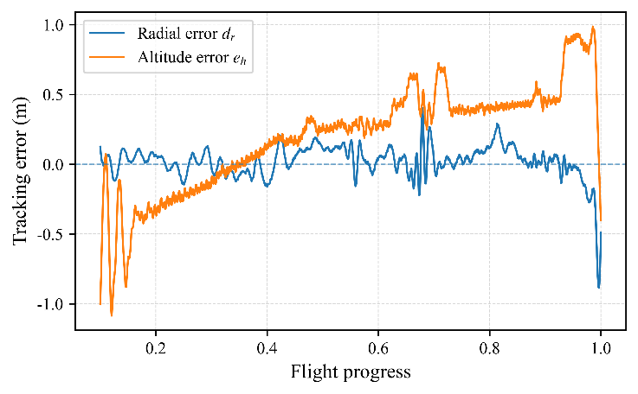 | 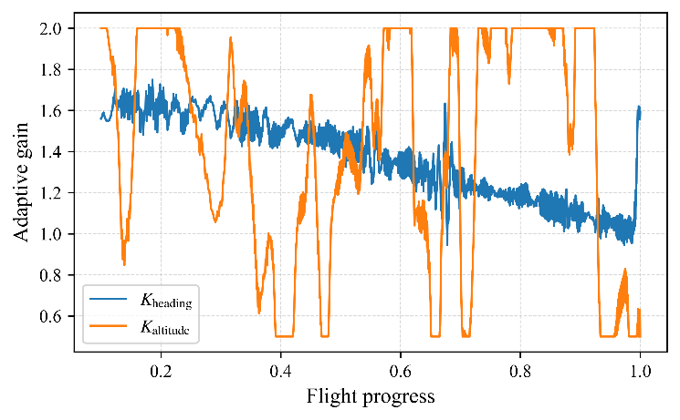
(a) | (b)
Figure 8. Tracking-error response and adaptive gain variation of the TD3 controller in a representative no-wind episode. (a) Radial and altitude tracking errors; (b) Variation of $K_{\text{heading}}$ and $K_{\text{altitude}}$.

4.3. Robustness Evaluation under Wind Disturbance
To further evaluate the robustness of the proposed TD3-based adaptive navigation controller, additional comparative experiments were conducted under wind-disturbance conditions. In this experiment, a 5 m/s wind disturbance was applied in the Gazebo environment from the beginning of each episode. The fixed-gain conical spiral navigation controller with $K=0.8$ was selected as the baseline method, and the trained TD3 policy was evaluated without exploration noise. Both controllers were tested using the same 20 initial flight scenarios, and the evaluation metrics were calculated from the flight phase satisfying $progress≥0.10$.
Figure 9 shows the trajectory-tracking comparison under wind-disturbance conditions. The desired conical spiral trajectory is plotted as a dashed curve, while the actual trajectories of the fixed-gain controller and the TD3 controller are shown in the planar and three-dimensional views. Compared with the no-wind case, the wind field introduces stronger lateral deviations and increases the difficulty of maintaining the desired spiral path. The fixed-gain controller exhibits a larger offset from the reference trajectory because its navigation gain remains unchanged during flight. In contrast, the TD3 controller can adaptively regulate the navigation gains according to the real-time tracking state, resulting in a trajectory that remains closer to the desired conical spiral path.
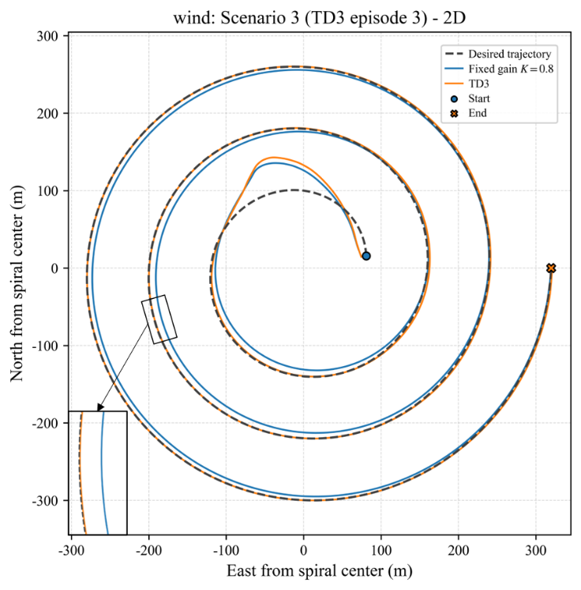 | 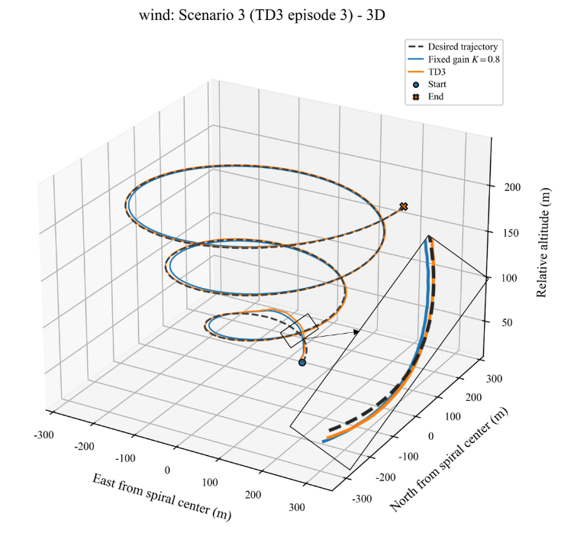
(a) | (b)
Figure 9. Trajectory-tracking comparison under wind-disturbance conditions. (a) Planar projection of the conical spiral trajectory; (b) Three-dimensional conical spiral trajectory.
Under wind-disturbance conditions, several episodes were terminated before completing the full conical spiral trajectory because the radial-error limit was triggered. These incomplete episodes were not treated as invalid log errors, because they directly reflect the robustness of the controllers under external disturbance. However, directly mixing incomplete and complete episodes in the tracking-error statistics would be unfair, since incomplete episodes only cover a short initial flight segment. Therefore, the completion rate was calculated over all 20 wind-disturbed evaluation episodes, while the tracking-error metrics were calculated only over the 15 scenarios completed by both the fixed-gain controller and the TD3 controller. This ensures that the error statistics are compared over complete conical spiral tracking processes.
Table 4. Robustness and tracking metrics under wind-disturbance conditions.
Metric | Fixed Gain $K=0.8$ | TD3
Completed episodes ↑ | 16/20 | 17/20
Mean $|d_{r}|$ (m) ↓ | 6.417 ± 0.171 (6.687) | 1.423 ± 0.215 (1.749)
RMSE of $d_{r}$ (m) ↓ | 8.139 ± 0.605 (9.116) | 5.218 ± 1.035 (6.755)
Max $|d_{r}|$ (m) ↓ | 45.300 ± 7.867 (57.193) | 46.462 ± 6.979 (58.159)
Mean $|e_{h}|$ (m) ↓ | 0.720 ± 0.004 (0.729) | 0.514 ± 0.003 (0.518)
RMSE of $e_{h}$ (m) ↓ | 0.789 ± 0.003 (0.796) | 0.557 ± 0.003 (0.560)
Max $|e_{h}|$ (m) ↓ | 1.148 ± 0.003 (1.152) | 1.040 ± 0.004 (1.046)
Episode reward ↑ | -14777.571 ± 4353.263 (-9512.723) | -9174.945 ± 4216.049 (-4150.882)
Note: Values are reported as mean ± standard deviation (maximum) over 20 evaluation episodes. The symbol ↓ indicates that a smaller value is better, while ↑ indicates that a larger value is better.
As shown in Table 4, the TD3 controller achieves a higher completion rate than the fixed-gain controller under wind disturbance. Specifically, TD3 completes 17 out of 20 episodes, while the fixed-gain baseline completes 16 episodes. This indicates that the adaptive gain adjustment learned by TD3 improves task robustness under external wind disturbance.
For the 15 common completed scenarios, TD3 significantly reduces the radial tracking error. The mean absolute radial error decreases from 6.417 m to 1.423 m, corresponding to a reduction of 77.82%. The radial RMSE decreases from 8.139 m to 5.218 m. These results show that TD3 can suppress wind-induced lateral deviations more effectively than the fixed-gain controller. Although the mean maximum radial error of TD3 is slightly higher than that of the fixed-gain controller, the difference is small and mainly reflects local transient peaks during the flight process.
The altitude-tracking performance is also improved by TD3. Compared with the fixed-gain baseline, the altitude MAE decreases from 0.720 m to 0.514 m, the altitude RMSE decreases from 0.789 m to 0.557 m, and the maximum altitude error decreases from 1.148 m to 1.040 m. In addition, TD3 obtains a higher average episode reward, increasing from -14777.571 to -9174.945. Since the reward function jointly considers radial tracking accuracy, altitude tracking stability, action smoothness, and flight progress, the higher reward indicates that TD3 achieves a better overall balance under wind disturbance.
To further explain the adaptive behaviour of the TD3 controller under wind disturbance, Figure 10 shows the tracking-error response and gain variation in a representative completed episode. Figure 10(a) presents the radial and altitude tracking errors, and Figure 10(b) shows the corresponding variation of $K_{heading}$ and $K_{altitude}$. The two gains vary continuously during the flight, indicating that the trained actor network adjusts the navigation gains according to the real-time tracking state. This adaptive regulation helps compensate for wind-induced deviations and improves the robustness of conical spiral trajectory tracking.
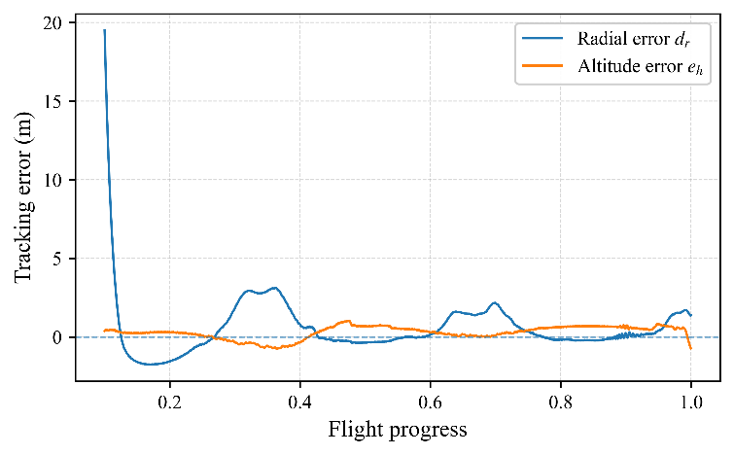 | 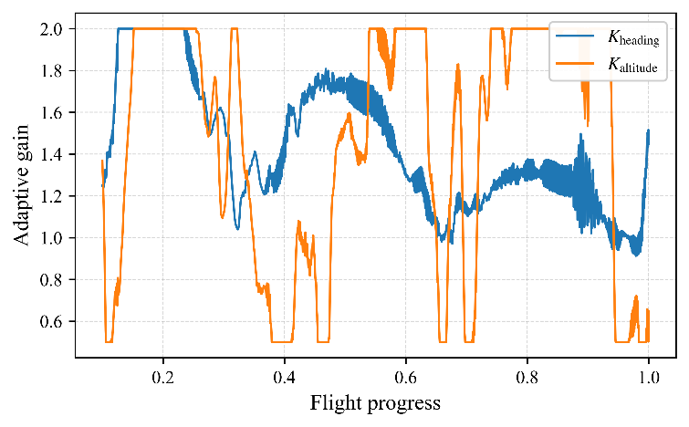
(a) | (b)
Figure 10. Tracking-error response and adaptive gain variation of the TD3 controller in a representative wind-disturbed episode. (a) Radial and altitude tracking errors; (b) Variation of $K_{heading}$ and $K_{altitude}$.

4.4. Multi-Scenario Robustness Analysis
To further verify the stability of the TD3-based adaptive controller under different initial test conditions, a multi-scenario robustness analysis was conducted using 20 different initial scenarios. Different from a uniformly distributed entry-angle experiment, the scenarios in this study were generated with different initial positions and initial headings. Therefore, this section mainly evaluates the cross-scenario stability of the controllers under different initial test conditions, rather than claiming all-directional entry-angle robustness.
Figure 11 shows the distribution of the initial positions of the 20 test scenarios in the local east–north coordinate frame. The initial positions are spatially dispersed, indicating that these tests were not repeated from the same initial state but covered different starting positions and heading conditions. Therefore, this set of test scenarios can be used to evaluate the trajectory-tracking consistency of the controllers under different initial conditions.
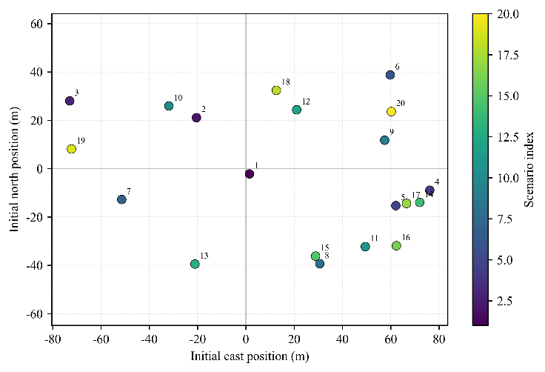
Figure 11. Distribution of the initial positions of the 20 test scenarios in the local east–north coordinate frame.
Figure 12 presents the scenario-wise radial RMSE comparison under the no-wind condition and the 5 m/s wind-disturbance condition. Under the no-wind condition, both FixedGain K=0.8 and TD3 completed all 20 scenarios. TD3 achieved a lower radial RMSE than FixedGain K=0.8 in 18 out of the 20 scenarios, indicating that the error reduction was not dominated by a few isolated cases but was observed under most initial test conditions. Under the 5 m/s wind disturbance, FixedGain K=0.8 completed 16 out of 20 scenarios, while TD3 completed 17 out of 20 scenarios. To avoid bias caused by incomplete trajectories, the radial RMSE comparison was performed only on the common scenarios completed by both controllers. In these common completed scenarios, TD3 achieved a lower radial RMSE than FixedGain K=0.8 in all 15 scenarios.
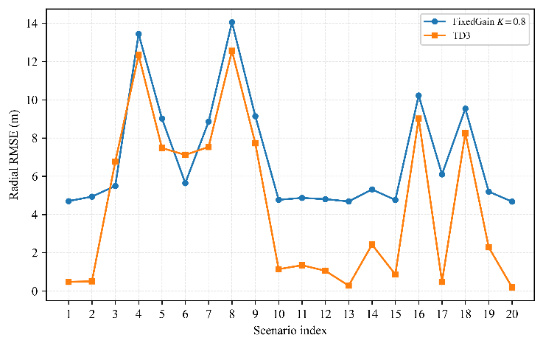 | 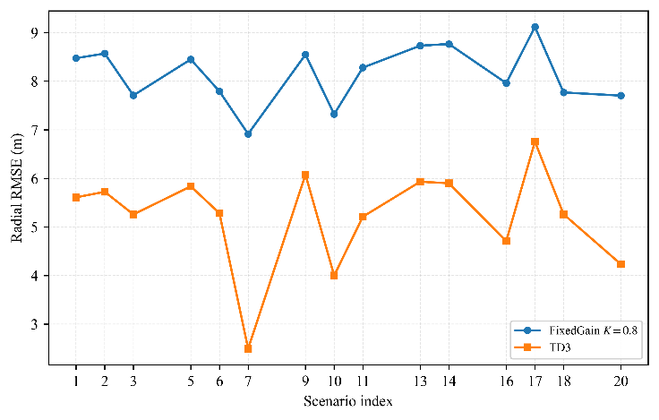
(a) | (b)
Figure 12. Scenario-wise radial RMSE comparison between FixedGain K=0.8 and TD3 under no-wind and 5 m/s wind-disturbance conditions. Figure 12. Scenario-wise radial RMSE comparison between FixedGain K = 0.8 and TD3. (a) No-wind condition; (b) 5 m/s wind-disturbance condition.
The paired statistical tests further show that, under both no-wind and wind-disturbance conditions, the improvements of TD3 in the major performance metrics, including mean radial error, radial RMSE, mean altitude error, and altitude RMSE, are statistically significant. Both the paired t-test and the Wilcoxon signed-rank test give p < 0.001 for these major metrics. It should be noted that the maximum-error metrics are more sensitive to local transient peaks, and therefore their stability is weaker than that of the mean-error and RMSE metrics. For this reason, the mean error and RMSE are used as the primary performance indicators, while the maximum error is reported as a supplementary metric.
Overall, the multi-scenario results demonstrate that the TD3-based adaptive controller not only reduces the tracking error in representative trajectories but also provides better cross-scenario robustness and consistency under different initial positions, initial headings, and wind-disturbance conditions.

5. Discussion
The simulation results show that the proposed TD3-based adaptive navigation controller improves the trajectory-tracking performance of the fixed-wing UAV during three-dimensional conical spiral flight. Compared with the FixedGain K = 0.8 controller, TD3 can adjust the heading and altitude navigation gains online according to the real-time tracking state, rather than using a fixed gain throughout the flight.
Under no-wind conditions, TD3 significantly reduces the radial tracking error and improves the average altitude-following performance. Under the 5 m/s wind-disturbance condition, TD3 also achieves a higher completion rate and lower radial and altitude errors over the common completed scenarios. These results indicate that the learned continuous gain-adjustment policy can improve both nominal tracking accuracy and disturbance rejection.
The multi-scenario evaluation further shows that the improvement of TD3 is not limited to a single representative trajectory. The 20 test scenarios were generated with different initial positions and initial headings. TD3 achieves lower radial RMSE than the fixed-gain controller in most no-wind scenarios and in all common completed wind-disturbed scenarios. This confirms that the proposed method provides better cross-scenario robustness and consistency.
Nevertheless, this study still has several limitations. First, the validation is currently based on the ArduPilot–Gazebo SITL platform, and real-flight tests are still re-quired. Second, only a constant 5 m/s wind disturbance is considered, while more complex wind conditions should be investigated in future work. Third, this study focuses on trajectory-tracking accuracy, and the influence of the proposed control method on final mapping quality still needs to be directly evaluated.

6. Conclusions
This paper proposes a TD3-based adaptive navigation-control method for fixed-wing UAV three-dimensional conical spiral trajectory tracking. By integrating TD3 with the conical spiral navigation framework, the proposed controller can continuously adjust the heading and altitude navigation gains according to real-time flight states.
The ArduPilot–Gazebo SITL results show that TD3 outperforms the FixedGain K = 0.8 controller under both no-wind and 5 m/s wind-disturbance conditions. Under no-wind conditions, TD3 reduces radial tracking error and improves altitude-tracking accuracy. Under wind disturbance, TD3 achieves a higher completion rate and better tracking accuracy over the common completed scenarios, demonstrating stronger robustness against external disturbance.
The multi-scenario analysis also confirms that TD3 provides more consistent performance under different initial positions and headings. Overall, the proposed method offers an effective continuous-action reinforcement-learning solution for adaptive navigation-gain control in fixed-wing UAV conical spiral tracking. Future work will focus on real-flight validation, more complex wind fields, and direct evaluation of mapping-quality indicators.

6. Patents
Author Contributions: Conceptualization, K.H., J.-S.Z., W.G. and D.C.; methodology, K.H., J.Z., C.L. and W.G.; software, K.H., C.L., W.H., C.W. and X.X.; validation, K.H., J.Z., C.L., W.H., Y.W. and C.W.; formal analysis, K.H., J.Z., X.W. and W.G.; investigation, K.H., J.Z., C.L., W.H., Y.W., C.W. and X.X.; resources, J.-S.Z., D.C. and W.G.; data curation, K.H., C.L., W.H., C.W. and X.W.; writing—original draft preparation, K.H.; writing—review and editing, J.Z., J.-S.Z., W.G. and D.C.; visualization, K.H., C.L., C.W. and X.W.; supervision, J.-S.Z., W.G. and D.C.; project administration, J.-S.Z. and D.C.; funding acquisition, J.-S.Z. and D.C. All authors have read and agreed to the published version of the manuscript.
Funding: This research was funded by Fujian Provincial Transportation Science and Technology Project (No. ZH202318) and Fujian Provincial Natural Science Foundation Project (Innovative Youth)： Spatiotemporal Trajectory Representation Learning Methods for Traffic Prediction (Fund No.2024J08111).
Data Availability Statement: The data presented in this study are available on request from the corresponding authors.
Acknowledgments: In this section, you can acknowledge any support given which is not covered by the author contribution or funding sections. This may include administrative and technical support, or donations in kind (e.g., materials used for experiments). Where GenAI has been used for purposes such as generating text, data, or graphics, or for study design, data collection, analysis, or interpretation of data, please add “During the preparation of this manuscript/study, the author(s) used [tool name, version information] for the purposes of [description of use]. The authors have reviewed and edited the output and take full responsibility for the content of this publication.”
Conflicts of Interest: The authors declare no conflicts of interest.

References
- Ding, W.; Wang, Y.; Chu, P.; Chen, F.; Song, Y.; Zhang, N.; Lin, D. Safety-Oriented Planning of Expressway Truck Service Areas Based on Driver Demand. Frontiers in public health 2022, 10, 976495.
- Bao, Z.; Hossain, S.; Lang, H.; Lin, X. A Review of High-Definition Map Creation Methods for Autonomous Driving. Engineering Applications of Artificial Intelligence 2023, 122, 106125.
- Elghazaly, G.; Frank, R.; Harvey, S.; Safko, S. High-Definition Maps: Comprehensive Survey, Challenges, and Future Perspectives. IEEE Open Journal of Intelligent Transportation Systems 2023, 4, 527–550.
- Štroner, M.; Urban, R.; Seidl, J.; Reindl, T.; Brouček, J. Photogrammetry Using UAV-Mounted GNSS RTK: Georeferencing Strategies without GCPs. Remote Sensing 2021, 13, 1336.
- DS, D.S.; N, M.; S, S.; R, J.; G, M. Influence of Quantity, Quality, Horizontal and Vertical Distribution of Ground Control Points on the Positional Accuracy of UAV Survey. Applied Geomatics 2023, 15, 897–917.
- Martínez-Carricondo, P.; Agüera-Vega, F.; Carvajal-Ramírez, F. Accuracy Assessment of RTK/PPK UAV-Photogrammetry Projects Using Differential Corrections from Multiple GNSS Fixed Base Stations. Geocarto International 2023, 38, 2197507.
- Doroż, A.; Bożek, P.; Taszakowski, J.; Janus, J. Use of UAV Imagery for Land Consolidation: Analysis of the Accuracy of the Resulting Orthophotomosaic in Relation to the GNSS RTK Measurement. Applied Geomatics 2024, 16, 561–573.
- Malić, B.; Moser, V.; Rajle, D.; Kulić, S.; Barišić, I. Comparative Assessment of Vertical Precision of Unmanned Aerial Vehicle-Based Geodetic Survey for Road Construction: A Multi-Platform and Multi-Software Approach. Infrastructures 2025, 10, 287.
- Nelson, D.R.; Barber, D.B.; McLain, T.W.; Beard, R.W. Vector Field Path Following for Miniature Air Vehicles. IEEE Transactions on Robotics 2007, 23, 519–529.
- Rysdyk, R. UAV Path Following for Constant Line-of-Sight. In Proceedings of the 2nd AIAA" Unmanned Unlimited" Conf. and Workshop & Exhibit; 2003; p. 6626.
- Park, S.; Deyst, J.; How, J. A New Nonlinear Guidance Logic for Trajectory Tracking. In Proceedings of the AIAA guidance, navigation, and control conference and exhibit; 2004; p. 4900.
- Beard, R.W.; McLain, T.W. Small Unmanned Aircraft: Theory and Practice; Princeton university press, 2012; ISBN 1-4008-4060-0.
- Ratnoo, A.; Sujit, P.B.; Kothari, M. Adaptive Optimal Path Following for High Wind Flights. IFAC Proceedings Volumes 2011, 44, 12985–12990.
- Qi, W.; Tong, M.; Wang, Q.; Song, W.; Ying, H. Curved-Line Path-Following Control of Fixed-Wing Unmanned Aerial Vehicles Using a Robust Disturbance-Estimator-Based Predictive Control Approach. Applied Sciences 2023, 13, 11577.
- de Marina, H.G.; Bronz, M.; Hattenberger, G. Guiding Vector Fields in Paparazzi Autopilot. arXiv preprint arXiv:2106.10680 2021.
- Zhao, J.; Li, J.; Zeng, L. Energy-Harvesting Strategy Investigation for Glider Autonomous Soaring Using Reinforcement Learning. Aerospace 2023, 10, 895.
- Silver, D.; Lever, G.; Heess, N.; Degris, T.; Wierstra, D.; Riedmiller, M. Deterministic Policy Gradient Algorithms. In Proceedings of the International conference on machine learning; Pmlr, 2014; pp. 387–395.
- Bouhamed, O.; Ghazzai, H.; Besbes, H.; Massoud, Y. Autonomous UAV Navigation: A DDPG-Based Deep Reinforcement Learning Approach. In Proceedings of the 2020 IEEE International Symposium on circuits and systems (ISCAS); IEEE, 2020; pp. 1–5.
- Schulman, J.; Wolski, F.; Dhariwal, P.; Radford, A.; Klimov, O. Proximal Policy Optimization Algorithms. arXiv preprint arXiv:1707.06347 2017.
- Yin, Y.; Wang, Z.; Zheng, L.; Su, Q.; Guo, Y. Autonomous UAV Navigation with Adaptive Control Based on Deep Reinforcement Learning. Electronics 2024, 13, 2432.
- Ikli, S.; Quenel, I. Autonomous Drone Takeoff and Navigation Using Reinforcement Learning: In Proceedings of the Proceedings of the 16th International Conference on Agents and Artificial Intelligence; SCITEPRESS - Science and Technology Publications: Rome, Italy, 2024; pp. 63–71.
- Olivares, D.; Fournier, P.; Vasishta, P.; Marzat, J. Model-Free versus Model-Based Reinforcement Learning for Fixed-Wing UAV Attitude Control under Varying Wind Conditions. arXiv preprint arXiv:2409.17896 2024.
- Fujimoto, S.; Hoof, H.; Meger, D. Addressing Function Approximation Error in Actor-Critic Methods. In Proceedings of the International conference on machine learning; PMLR, 2018; pp. 1587–1596.
- Sutton, R.S.; Barto, A.G. Reinforcement Learning: An Introduction; MIT press Cambridge, 1998; Vol. 1;.
Disclaimer/Publisher’s Note: The statements, opinions and data contained in all publications are solely those of the individual author(s) and contributor(s) and not of MDPI and/or the editor(s). MDPI and/or the editor(s) disclaim responsibility for any injury to people or property resulting from any ideas, methods, instructions or products referred to in the content.

